Rewinding Coding Machine ZRD-220
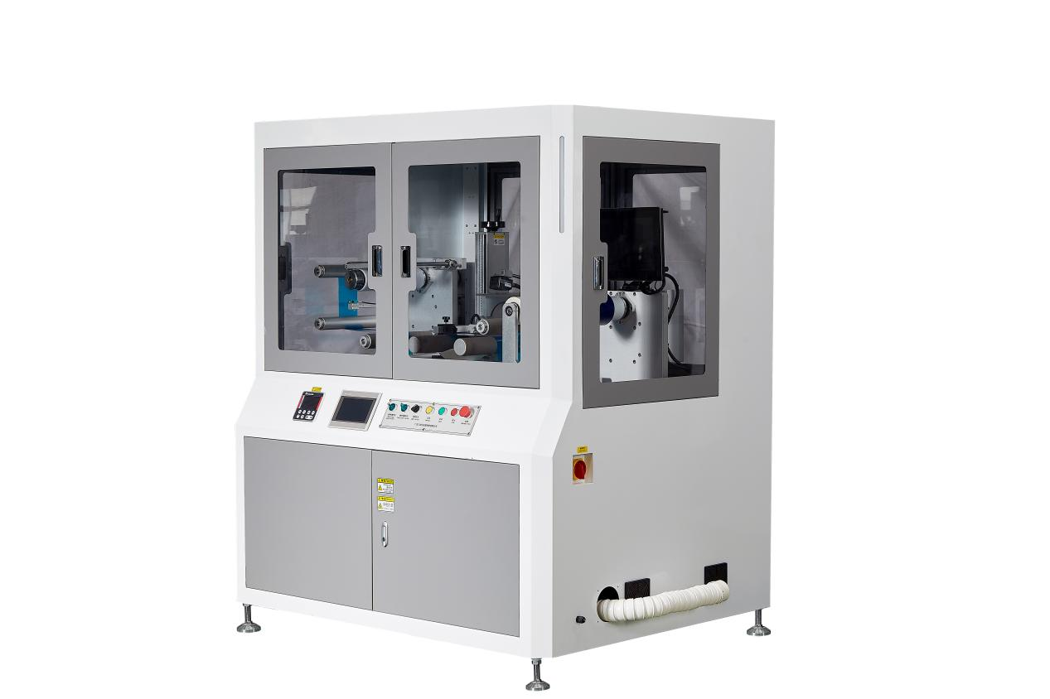
Basic Use：
Mainly used for laser coding and rewinding of various coiled materials.

Equipment Advantages：
- Human-machine interface with microcomputer programmable control.
- Equipped with three-servo control system. Servo motors control rewinding and unwinding tension to ensure stable and reliable material tension; servo positioning film feeding with adjustable length.
- Adopts high-precision water-cooled ultraviolet laser.
- Adjustable coding quantity for products.
- Easy operation, automatic fault alarm and one-key intelligent operation.

Main Technical Parameters：
Model | ZRD-220 Rewinding Coding Machine
Material Width | 50-220mm
Material Diameter | Max outer diameter: 245mm (core diameter: 76mm)
Coding Speed | Depends on coding requirements
Mechanical Allowable Speed | 0-30m/min
Laser Type | 10W UV Laser (355nm)
Voltage and Power | AC220V 2.6KW
Air Pressure | 0.5mpa
Machine Dimensions | 1620mm*1380mm*1750mm
Net Weight | 1600KG

Configuration Parameters:
Model | Rewinding Coding Machine ZRD-220
Touch Screen | HMI
Servo Roll Feed | HCFA
Roll Feeding Driver | HCFA
Fixed-length Servo | HCFA
Fixed-length Driver | HCFA
Rewinding Servo | HCFA
Rewinding Driver | HCFA
Laser Coding Machine | KEXIN
Laser Galvo Scanner | KEXIN
Reducer | Smart
Detection Fiber | KEYENCE
PLC | HCFA
Air Switch | CHINT
Switching Power Supply | MEAN WELL
Deviation Correction | Youdao
Relay | IDEC
Push Button Switch | Schneider
Cylinder | XINGCHEN
Filter | STNC
Solenoid Valve | STNC
Magnetic Switch | AirTAC
Bearing | NSK
Frame | Imported Powder Coating
Motion Controller | HCFA
Photoelectric Sensor | Boyee
Guide Rail | HIWIN

